**User Interface Design**

**Version 1.0**

**Project Management App**

**Team A**

**CSC-354**

**Fall 2015**

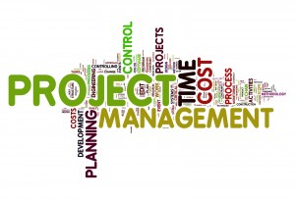

11/12/2015

Author:

Submitted To: Dr. Joo Tan

**TABLE OF CONTENTS**

Revision History…………………………………………………………………………………..ii

1.0 Introduction……..….....…………………………….…...…………………………….……....1

1.1 What Is User Interface Design?............………....……………………………….........1

**REVISION HISTORY**

|  |  |  |  |
| --- | --- | --- | --- |
| Version | Author | Description | Date |
| 1.0 | Hector Richiez | I created the frame that will be using for UID | 11/08/2015 |

**1.0 INTRODUCTION**

**1.1 what is User Interface Design?**

User Screen Output

Stuff goes here like button to tell the user to create an account. This is flow of interaction diagrams. What we will be using to create the UID. For more info, it is in the book page 155

process

Here goes what happen when the leader clicks the create account button. Which is probably a button to create a project, add member and so on.

Leader clicks “Create Account”

Leader